**w**

Software Requirements Specification

for

LFG-IRL

**Version 1.0 approved**

**Prepared by: The General**

**Beardmore, Zachary; Cai, Yide; Day, Brennan;**

**Dunn, Korbin; Hester, Travis; Jaiswar, Rahul;**

**Kresta, Cody; Macjones, Grace; Ortiz, Liliana;**

**Seddon, Richard; Bhandari, Shradha; Roberson, James**

**9/20/2017**

**Table of Contents**

**1.** **Introduction 3**

1.1 Purpose 3

1.2 Intended Audience 3

1.3 Product Scope 3

**2.** **Overall Description 4**

2.1 Product Functions 4

2.2 User Scope 4

2.3 User Documentation 4

**3.** **External Interface Requirements 5**

3.1 User Interfaces 5

3.2 Desired Outputs and Required Inputs 8

**4.** **Other Nonfunctional Requirements 10**

4.1 Safety Requirements 10

4.2 Security Requirements 10

# Introduction

## 1.1 Purpose

The purpose of this project is to help people connect with others who share a common interest to do legal and fun group activities with. It aims to create an easy to use application for finding groups. This will encourage healthy social behavior and allow people to make friends to engage with in hobbies and activities.

## 1.2 Intended Audience

This document is prepared to satisfy the software requirements specification for the application that will be developed as a final project for the Software Engineering class. This document will provide an overview of the requirements to better understand the scope and constraints of the project as well as the functionality of the product which includes its characteristics and type of users that will make use of the application. The application will also provide a scope of the ethical issues and decisions that the development may require.

## 1.3 Product Scope

It can be difficult to find people with whom an individual shares interests, and often they are limited to doing activities with people that they already know. For this reason it has been decided to develop a new product to meet the needs of individuals who seek to find people with same interest, knowledge and/or expertise. The main purpose of this application will be to overcome the limitations of trying to engage in selected activities that require several people. The benefit of such an application is that the users can physically meet people with whom they can enjoy outdoor activities, different types of games, volunteering and altruist events, or even seeing a movie. The application will provide the opportunity to seek other groups of people looking to do a specific activity, and also to create groups for others to join.

# Overall Description

## Product Functions

This application’s major objective is to provide a service that functions as an intermediary between users. In order to accomplish this objective the following functions will be implemented:

* Users will have a profile
* Users can search for groups
* Users can use filters for posts
* Users can chat with joined groups
* List of recent groups and users
* The ability to leave and join groups
* Groups can be created for specific events
* Groups can be deleted by the creator or after a specific period of inactivity after the set meeting date
* Vote kick system
* GPS integration for searching by location
* Group leader can set an age restriction
* Group leader can set group size
* Report/block system
* Cell phone and/or email verification
* Cell phone and/or email notifications
* Groups can be organized into teams automatically or by the user
* Dynamic group categories

## User Scope

The target audience for this product is responsible adults looking for others to participate in activities. Only users 18 years of age and older are intended to use this application.

## User Documentation

A brief tutorial and walkthrough for using the application will be provided, along with a general help section and frequently asked questions.

# External Interface Requirements

## User Interfaces

The user interface will consist of six main screens:

1. Login Screen

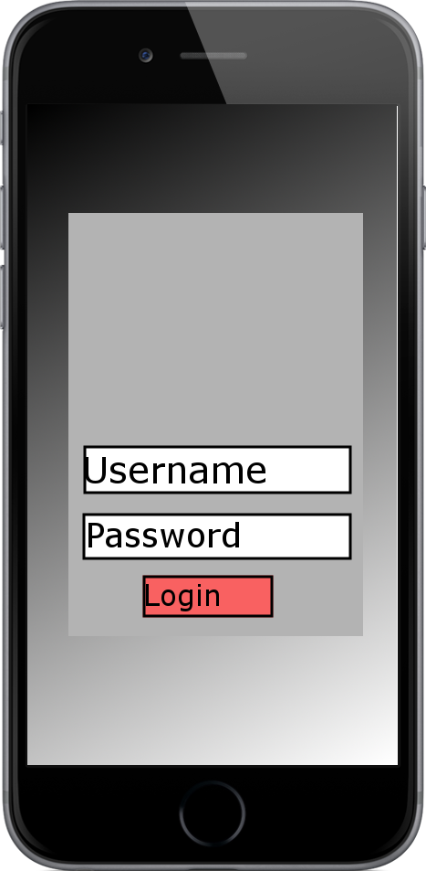

2. Topic Screen

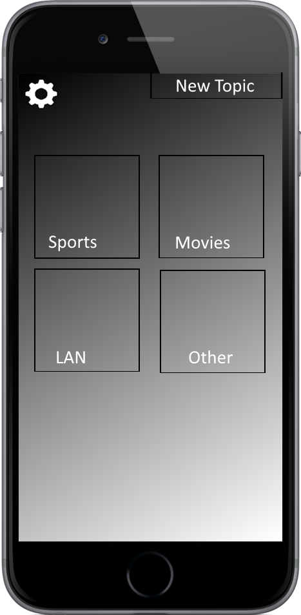

3. Group Browsing

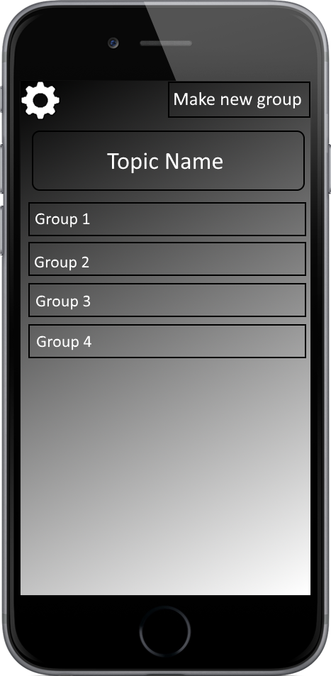

4. Group Viewing Screen

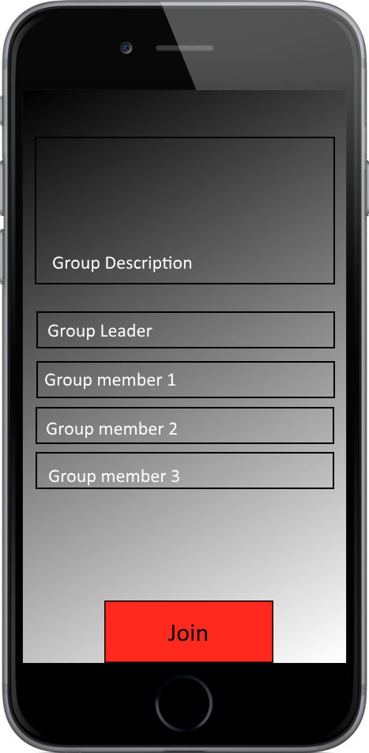

5. Group Chat

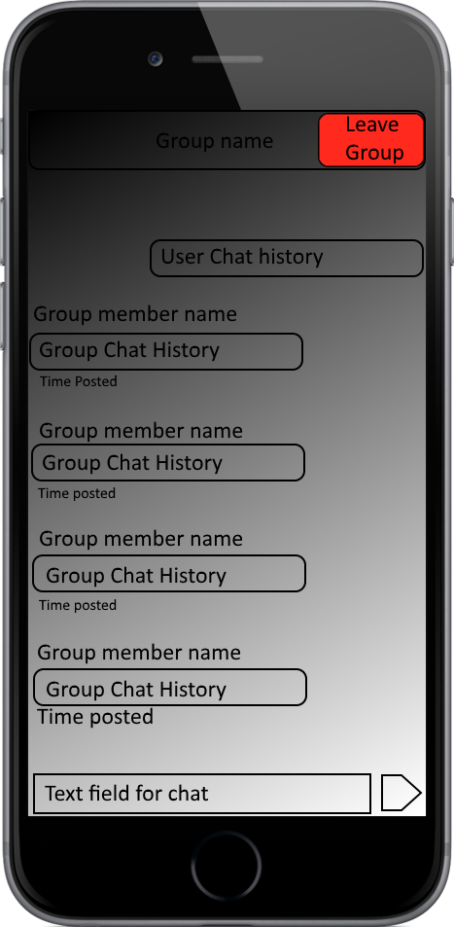

6. Profile/Settings Screen

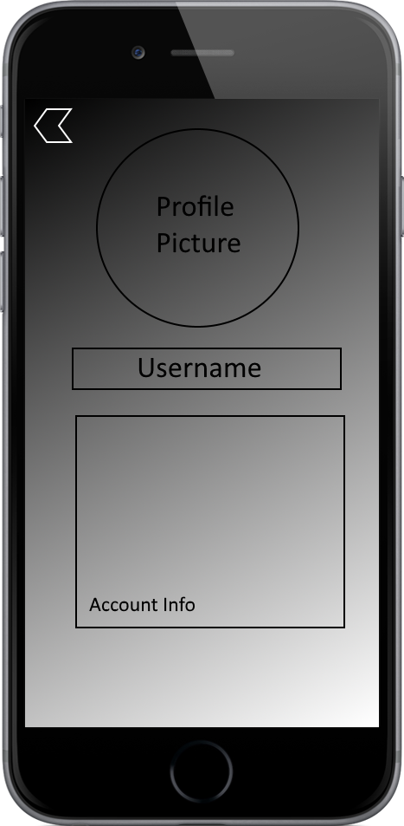

* 1. **Desired Outputs and Required Inputs**

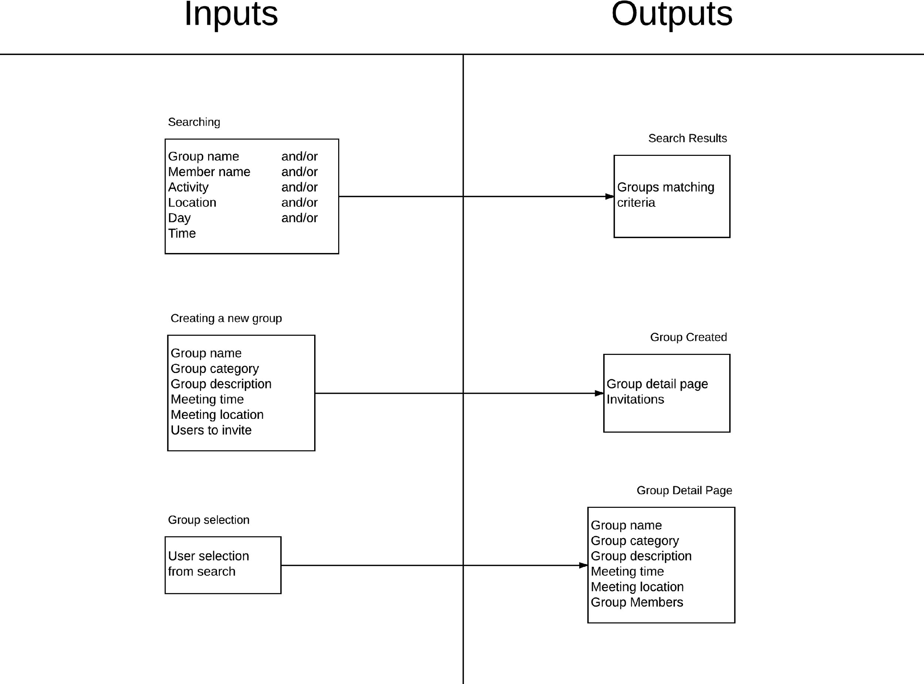



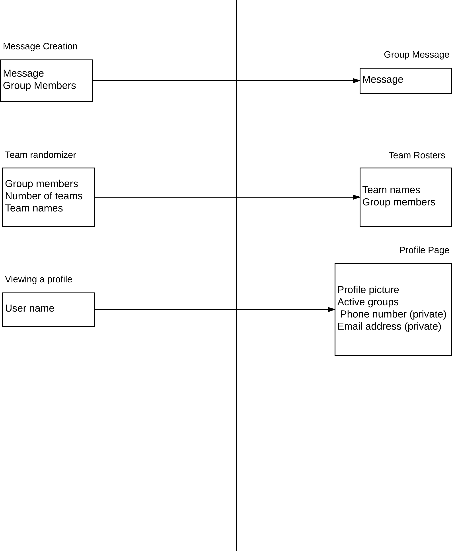

# Other Nonfunctional Requirements

## Safety Requirements

For safety purposes, a disclaimer will be shown and a terms and conditions policy must be accepted before users are granted access to the application. Users must acknowledge that they are legal adults and are responsible for their own decisions to meet up with people. The application merely provides people who want to meet up, a platform to find each other on, it does not have any role in whether they meet up or not. Users are advised to meet up in a public place before the group activity, and will be encouraged to report and block anyone requesting a private meeting. Users will also be encouraged to report any users that are harassing them or violating the terms and conditions.

## Security Requirements

Users will have a personal username and password and will be required to verify the account with their personal phone number. Email will also be used as a backup in case a password is forgotten. User data such as email, location, and phone number will not be visible or accessible to any other users.